
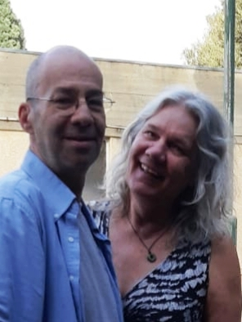
Lior / Rita
דברים בהלוויה
My love my sweetheart my partner my best friend, and as you always loved to say - my soul mate.
Its your birthday today. You would have been 54 years old. Far too young to leave this life already.
You won’t be opening the presents we got you this year, but the greatest and most magical gift you’ve already received. Your beautiful daughter Eden, the name you chose… for Paradise.
I don't know what you see from wherever you are right now, but Lior you would be so proud of her and how she is coping with your death. She is talking to you all the time.
But still...you’re gone. And that’s it. And there are so many feelings I’m trying to express but my head is jumbled and my heart is aching and I just cant find the words yet.
But I feel your presence so strongly here with me, so I am sure you can feel me too.
So I am sending you…
All my love
All my prayers and
All my hugs.
You will always be in my thoughts, Lior,
and I will feel your love in my heart forever.
I miss you so much my dear.
Rest in peace, beautiful man.
Your Rita… forever.



